NCHRP 20-07
Proposed Research Problem Statement

TITLE

Identifying Traffic Volume Estimation Methods and Potential Associated Effects of Estimated ADT Values on Safety Analysis

PROBLEM STATEMENT

With the development of several new safety analysis tools such as SafetyAnalyst and the Highway Safety Manual, comprehensive average daily traffic (ADT) data has become increasingly important for our safety programs. For many facility types, however, this data is currently not available and/or is simply estimated by a jurisdiction. The Strategic Highway Safety Plan (SHSP) requirements state that all public roads must be analyzed. Often state transportation agencies simply do not collect data on all roads – especially those facilities locally maintained by cities and counties within their region. A nationwide survey of state transportation agencies revealed that a majority of the states conduct traffic counts primarily on roadways with higher functional classification. The percentage of roadway miles with actual traffic counts can be expected to consistently decline with the decrease in the roadway function demand (such as lower functional classification roads). Often a state department of transportation will supplement the actual traffic count data with estimated values for roads that do not have actual traffic count data; however, the estimated traffic volumes are generated using a wide variety of estimation techniques resulting in potentially a wide variety of estimation errors.
Since transportation agencies use this traffic volume information for assessing safety and many of the facilities are characterized by a substantial percentage of estimated traffic counts, the reliability of any type of safety analysis will then depend on the accuracy and consistency of the ADT estimation procedure. For example, in one state, less than 25% of the actual ADT traffic data is collected. For this example, therefore, this state must estimate ADT values for more than 75% of the transportation facilities. Often, the locations selected for traffic volume measurement vary dramatically between urban and rural locations. The following graph demonstrates an example of the overall traffic estimations on rural multilane divided roadways in Georgia. The unrealistic pattern of crashes at very specific traffic volume values (often round figures such as 5,000 or 35,000 vehicles per day) brings into question the reliability of the data and may jeopardize the accuracy of associated safety analyses.
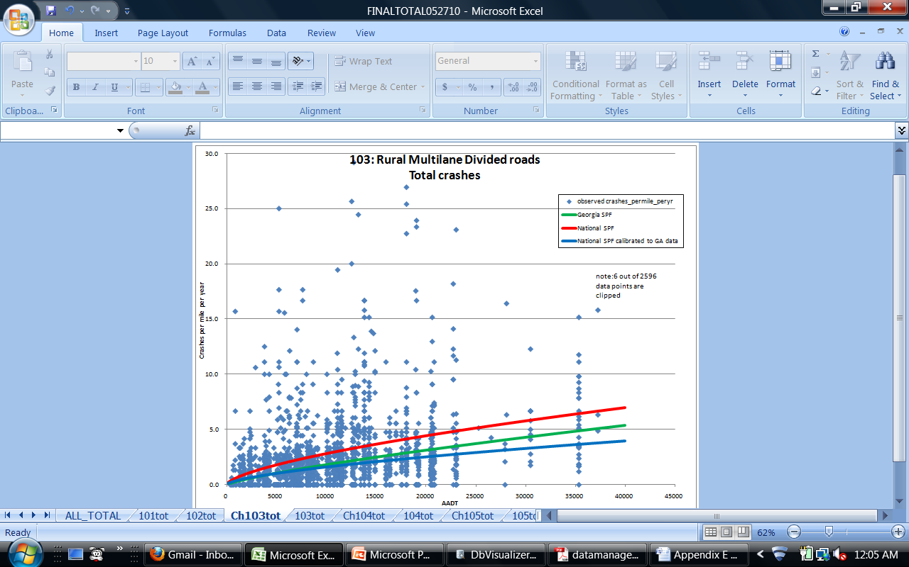
There is also an obvious bias associated with the development of SPFs using all available traffic information (estimated and actual) versus only using actual traffic counts in the analysis. In all instances where sufficient data existed for the state of Georgia example, SPFs developed using the traffic volume estimates exhibited greater scatter (higher over-dispersion parameters) than for those SPFs developed only using actual count data. For the Georgia two-lane rural SPF example, the over-dispersion parameter was reduced from 1.38 to 0.74. This is a significant difference. States should be cautioned, however, that the types of roads on which actual traffic counts are performed may be biased in comparison with those locations where these values are estimated, so a thorough review is needed to identify the potential impacts of these biases.
This proposed research would seek to determine best practices for obtaining, maintaining, and estimating ADT on a statewide basis. Specific examples of best practices would be highlighted, along with analysis of what problems can result due to inaccurate ADT values. Lack of ADT data is considered by many to be one of the biggest threats toward making large gains in the safety of our roadway systems. Questions that can be addressed include: What are states doing when they do not have data? What methods are used to populate the missing data values? Do states maintain information about estimated versus actual ADT? Are there ADT data defaults for certain functional classifications? Is there a bias associated with roadways selected for actual traffic counts? Does the state obtain information on traffic counts from local/city roads?

OBJECTIVES

The objectives of the proposed research are to (1) identify common traffic volume estimation techniques used by state agencies, (2) assess how these estimation techniques may influence safety estimates, and (3) develop a best practices report that summarizes this information and that can also serve as guidance to help transportation agencies enhance their traffic volume estimation techniques by using consistent estimation procedures that will minimize potential biases from safety assessment applications.

RESEARCH TASKS

The above objectives can be accomplished through the following tasks:
- Review the published traffic volume estimation procedures for various transportation agencies and document these findings,
- Conduct a survey of responsible transportation agencies to identify how they use their traffic volume information and what ADT estimation methods are common to their agency, and
- Evaluate the Highway Safety Manual safety prediction methods and how ADT estimation biases and errors may influence the accuracy of associated safety assessments. In addition, this assessment should be conceptually expanded to other common safety assessment tools.

FUNDING AND TIME DURATION REQUESTED
It is estimated that this research will take 12 months and will cost approximately $50,000.
PERSON(S) DEVELOPING THE PROBLEM STATEMENT
Jennifer Ogle, Ph.D., Clemson University (Email: ogle@clemson.edu)

Karen Dixon, Ph.D., P.E., Texas A&M Transportation Institute (Email: k-dixon@tamu.edu)

John Milton, Ph.D., P.E., Washington State Department of Transportation (Email: MiltonJ@wsdot.gov)

PROBLEM MONITOR
Priscilla Tobias, P.E., Chair AASHTO Subcommittee on Safety Management-Task Group Technical Safety Publication Oversight and Outreach, Illinois Department of Transportation (Email: Priscilla.Tobias@Illinois.gov)

John Milton, Ph.D., P.E., Chair TRB Highway Safety Performance Committee, Washington State Department of Transportation (Email: MiltonJ@wsdot.gov)

DATE AND SUBMITTED BY
April 1, 2013

AASHTO Safety Management Subcommittee,

Task Group for Technical Safety Publication Oversight and Outreach,

TRB Highway Safety Performance Committee

